SQL | DDL, DQL, DML, DCL and TCL Commands

Structured Query Language (SQL) as we all know is the database language by the use of which we can perform certain operations on the existing database and also, we can use this language to create a database. SQL uses certain commands like Create, Drop, Insert, etc. to carry out the required tasks.

These SQL commands are mainly categorized into four categories as:
- DDL – Data Definition Language
- DQl – Data Query Language
- DML – Data Manipulation Language
- DCL – Data Control Language
Though many resources claim there to be another category of SQL clauses TCL – Transaction Control Language. So we will see in detail about TCL as well.

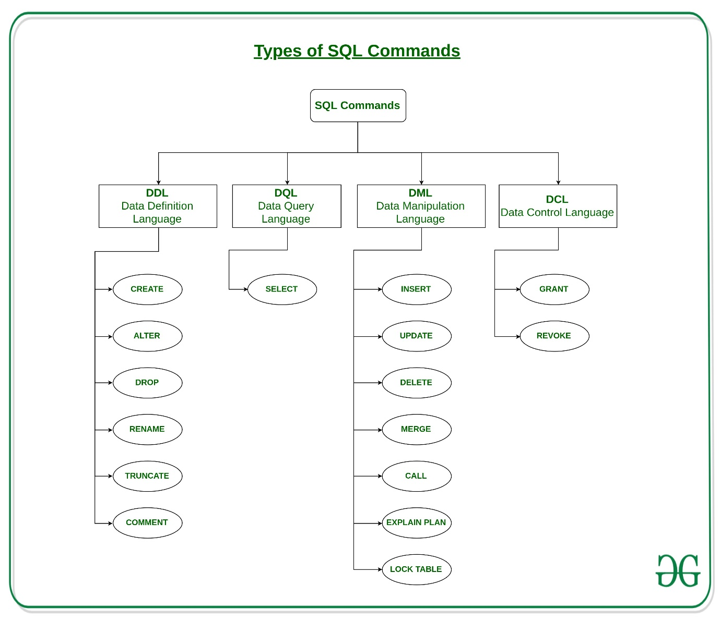

1.DDL(Data Definition Language) : DDL or Data Definition Language actually consists of the SQL commands that can be used to define the database schema. It simply deals with descriptions of the database schema and is used to create and modify the structure of database objects in the database.

Examples of DDL commands:
- CREATE – is used to create the database or its objects (like table, index, function, views, store procedure and triggers).
- DROP – is used to delete objects from the database.
- ALTER-is used to alter the structure of the database.
- TRUNCATE–is used to remove all records from a table, including all spaces allocated for the records are removed.
- COMMENT –is used to add comments to the data dictionary.
- RENAME –is used to rename an object existing in the database.
2.DQL (Data Query Language) :
DQL statements are used for performing queries on the data within schema objects. The purpose of the DQL Command is to get some schema relation based on the query passed to it.
Example of DQL:
- SELECT – is used to retrieve data from the database.
3.DML(Data Manipulation Language): The SQL commands that deals with the manipulation of data present in the database belong to DML or Data Manipulation Language and this includes most of the SQL statements.

Examples of DML:
- INSERT – is used to insert data into a table.
- UPDATE – is used to update existing data within a table.
- DELETE – is used to delete records from a database table.
4.DCL(Data Control Language): DCL includes commands such as GRANT and REVOKE which mainly deal with the rights, permissions and other controls of the database system.
Examples of DCL commands:
- GRANT-gives users access privileges to the database.
- REVOKE-withdraw user’s access privileges given by using the GRANT command.
TCL(transaction Control Language): TCL commands deal with the transaction within the database.
Examples of TCL commands:
- COMMIT– commits a Transaction.
- ROLLBACK– rollbacks a transaction in case of any error occurs.
- SAVEPOINT–sets a savepoint within a transaction.
- SET TRANSACTION–specify characteristics for the transaction.

Physical and Logical Data Independence
1. Physical Data Independence:
Physical Data Independence is defined as the ability to make changes in the structure of the lowest level of the Database Management System (DBMS) without affecting the higher-level schemas. Hence, modification in the Physical level should not result in any changes in the Logical or View levels.
Note –
There are 3 levels in the schema architecture of DBMS: physical level, logical level and view level (arranged from the lowest to highest level).

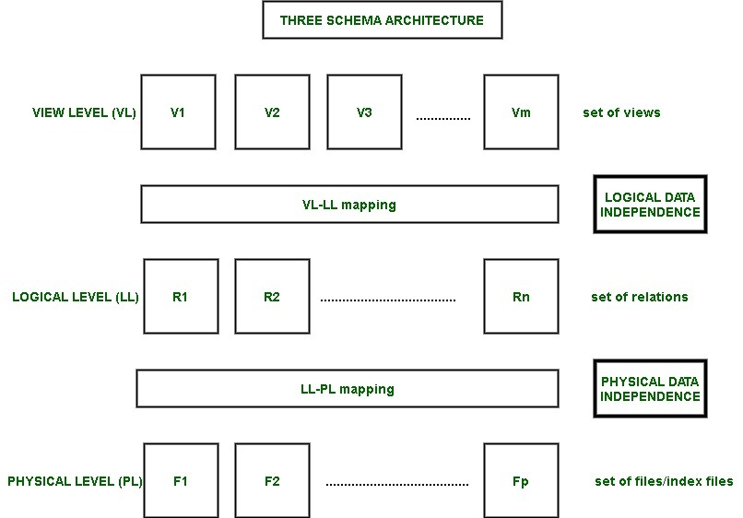

- Example –
Changes in the lowest level (physical level) are: creating a new file, storing the new files in the system, creating a new index etc.
Instances of why we may want to do any sort of Data modification in the physical level- We may want to alter or change the data in the physical level. This is because we may want to add or remove files and indexes to enhance the performance of the database system and make it faster. Hence, in this way, the Physical Data Independence enables us to do Performance Tuning. Ideally, when we change the physical level, we would not want to alter the logical and view level.
- How is Physical Data Independence achieved?
Physical Data Independence is achieved by modifying the physical layer to logical layer mapping (PL-LL mapping). We must ensure that the modification we have done is localized.
2. Logical Data Independence:
Logical Data Independence is defined as the ability to make changes in the structure of the middle level of the Database Management System (DBMS) without affecting the highest-level schema or application programs. Hence, modification in the logical level should not result in any changes in the view levels or application programs.
- Example –
Changes in the lowest level (physical level) are: adding new attributes to a relation, deleting existing attributes of the relation etc. Ideally, we would not want to change any application or programs that do not require to use the modified attribute.
- How is Logical Data Independence achieved ?
Logical Data Independence is achieved by modifying the view layer to logical layer mapping (VL-LL mapping).

Data Abstraction and Data Independence

Database systems comprise complex data-structures. In order to make the system efficient in terms of retrieval of data, and reduce complexity in terms of usability of users, developers use abstraction i.e. hide irrelevant details from the users. This approach simplifies database design.
There are mainly 3 levels of data abstraction:
Physical: This is the lowest level of data abstraction. It tells us how the data is actually stored in memory. The access methods like sequential or random access and file organization methods like B+ trees, hashing used for the same. Usability, size of memory, and the number of times the records are factors that we need to know while designing the database.
Suppose we need to store the details of an employee. Blocks of storage and the amount of memory used for these purposes are kept hidden from the user.
Logical: This level comprises the information that is actually stored in the database in the form of tables. It also stores the relationship among the data entities in relatively simple structures. At this level, the information available to the user at the view level is unknown.
We can store the various attributes of an employee and relationships, e.g. with the manager can also be stored.
View: This is the highest level of abstraction. Only a part of the actual database is viewed by the users. This level exists to ease the accessibility of the database by an individual user. Users view data in the form of rows and columns. Tables and relations are used to store data. Multiple views of the same database may exist. Users can just view the data and interact with the database, storage and implementation details are hidden from them.

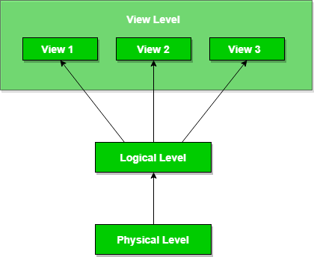

The main purpose of data abstraction is to achieve data independence in order to save time and cost required when the database is modified or altered.
We have namely two levels of data independence arising from these levels of abstraction:
Physical level data independence: It refers to the characteristic of being able to modify the physical schema without any alterations to the conceptual or logical schema, done for optimization purposes, e.g., Conceptual structure of the database would not be affected by any change in storage size of the database system server. Changing from sequential to random access files is one such example. These alterations or modifications to the physical structure may include:
- Utilizing new storage devices.
- Modifying data structures used for storage.
- Altering indexes or using alternative file organization techniques etc.
Logical level data independence: It refers characteristic of being able to modify the logical schema without affecting the external schema or application program. The user view of the data would not be affected by any changes to the conceptual view of the data. These changes may include insertion or deletion of attributes, altering table structures entities or relationships to the logical schema, etc.

